Supplementary Materials
Scenario analyses based on hemoglobin stabilization as model outcome

Supplemental Table 1. Odds ratios between transfusion-avoidant and transfusion-required populations hemoglobin stabilization, pooled arms
From | Transfusion required, % | Transfusion avoidant, % | Odds ratios (transfusion avoidant vs required)
To (at 26 weeks) | Transfusion required, % | Transfusion avoidant, % | Odds ratios (transfusion avoidant vs required)
Transfusion Avoidant | 62.86 | 78.57 | 2.17
Transfusion Required | 37.14 | 21.43 | 0.46

Supplemental Table 2. Probabilities for transfusion avoidant group – hemoglobin stabilization
Probabilities after 26 weeks |  | Transfusion avoidant, %
Transfusion avoidant | Hemoglobin stabilized | 95.97 | 91.61
Transfusion avoidant | Hemoglobin not stabilized | 95.97 | 4.36
Transfusion required |  | 4.03 | 4.03

Supplemental Table 3. Transition probabilities, comparators – hemoglobin stabilization
From | To
From | Hb stabilized, % | Hb not stabilized, % | Transfusion required,%
Eculizumab
Hb stabilized | 66.97 | 19.09 | 13.94
Hb not stabilized | 58.60 | 15.38 | 26.02
Transfusion required | 51.72 | 12.65 | 35.63
Ravulizumab
Hb stabilized | 62.77 | 23.49 | 13.74
Hb not stabilized | 54.06 | 20.23 | 25.71
Transfusion required | 47.11 | 17.63 | 35.26

Supplemental Figure 1. Transfusion Required health state structure

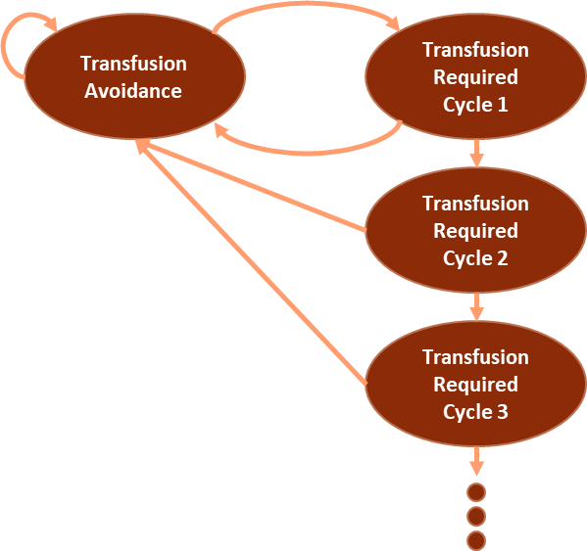

Supplemental Figure 2. Methodology of calculating transition probabilities for pegcetacoplan+BSC for (A) base-case model structure based on Hb normalization and (B) alternative model structure based on Hb stabilization
A) Hb normalization
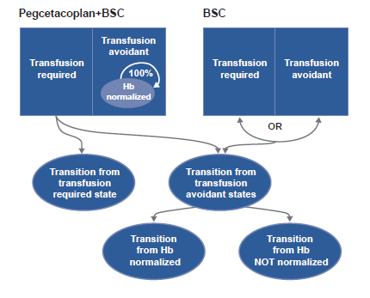
A) Hb stabilization
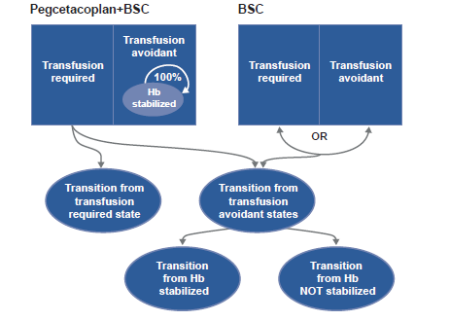

BSC: best supportive care, Hb: hemoglobin.
Supplemental Figure 3. Tornado diagrams of deterministic sensitivity analysis for pegcetacoplan versus (A) eculizumab and (B) ravulizumab
- Pegcetacoplan vs eculizumab 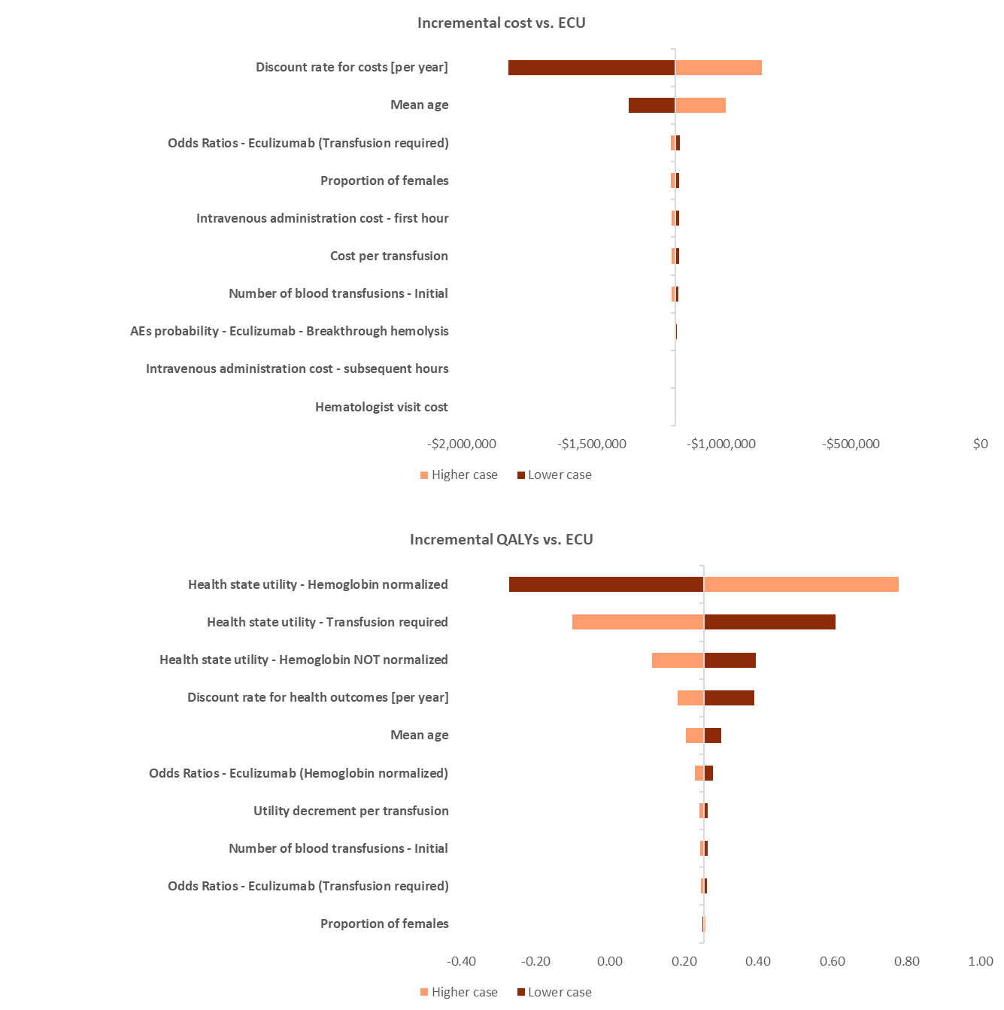
Incremental QALYs
Incremental costs

B) Pegcetacoplan versus ravulizumab
Incremental costs
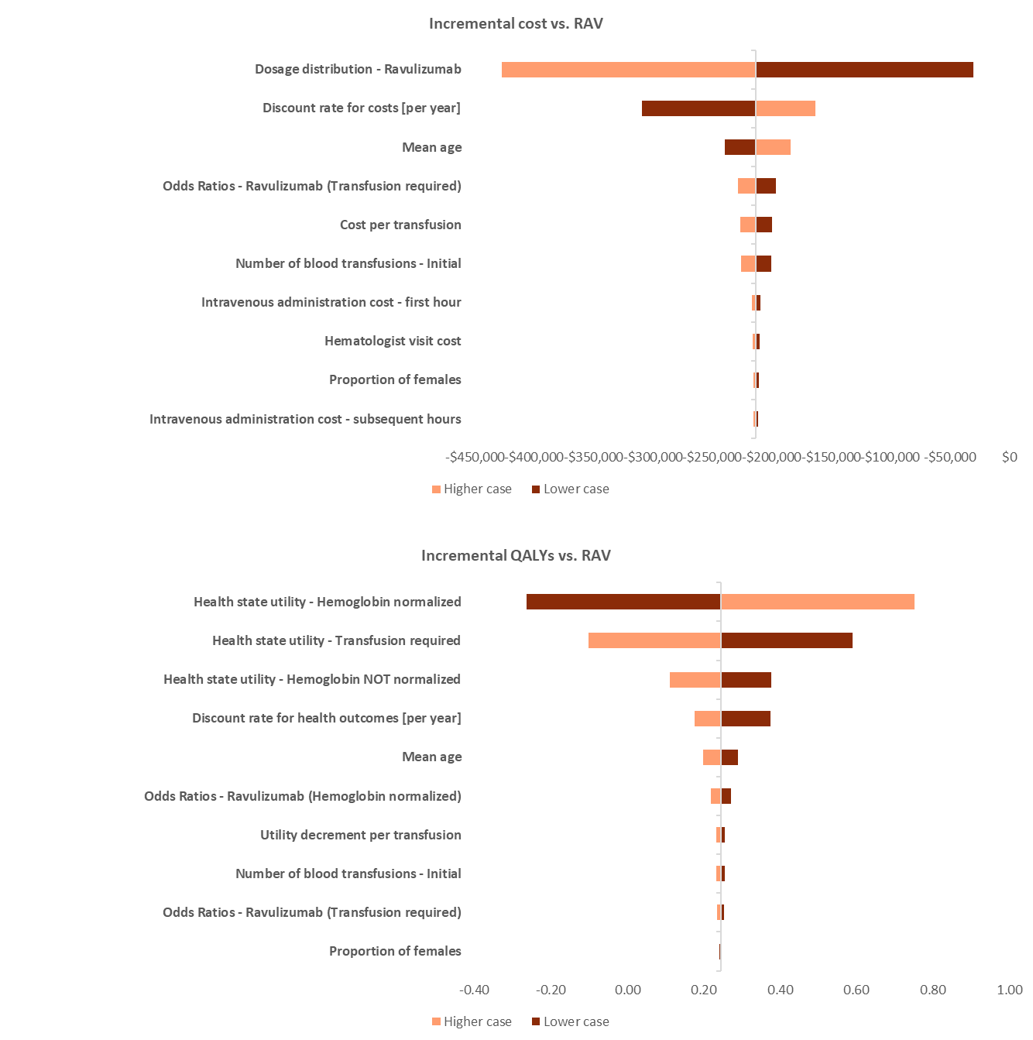
Incremental QALYs

AE: adverse event; QALY: quality-adjusted life year.
Supplemental Figure 4. Incremental cost-effectiveness planes: (A) pegcetacoplan versus eculizumab, (B) pegcetacoplan versus ravulizumab – based on hemoglobin stabilization
A) Pegcetacoplan versus eculizumab
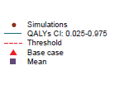
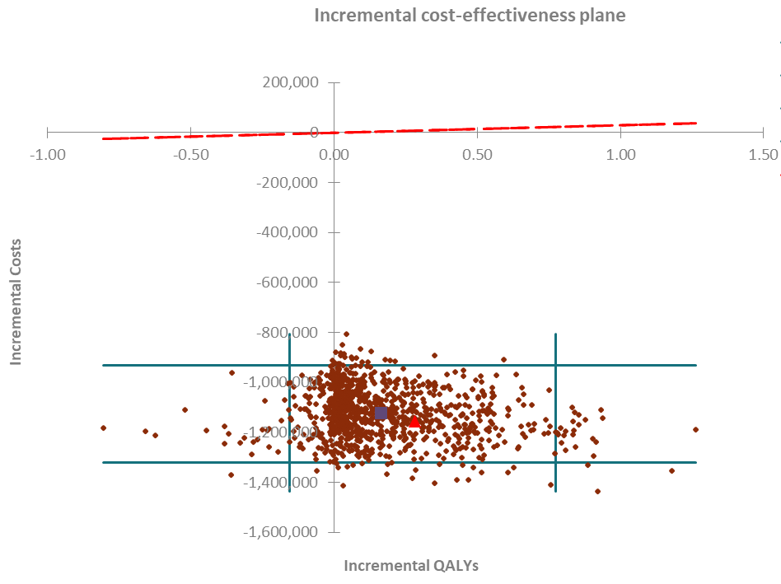

B) Pegcetacoplan versus ravulizumab
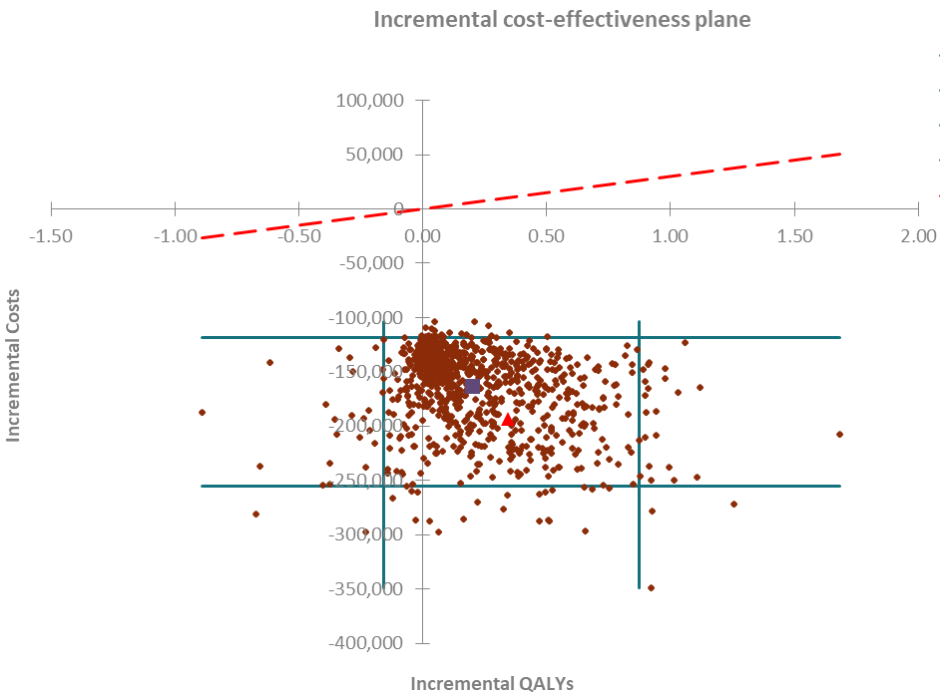

QALY: quality-adjusted life year.

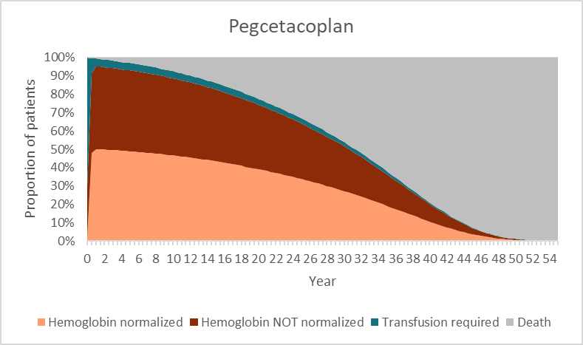
Supplemental Figure 5. Distribution of patients over time simulated by the CEM for pegcetacoplan, eculizumab, and ravulizumab

